Titel

[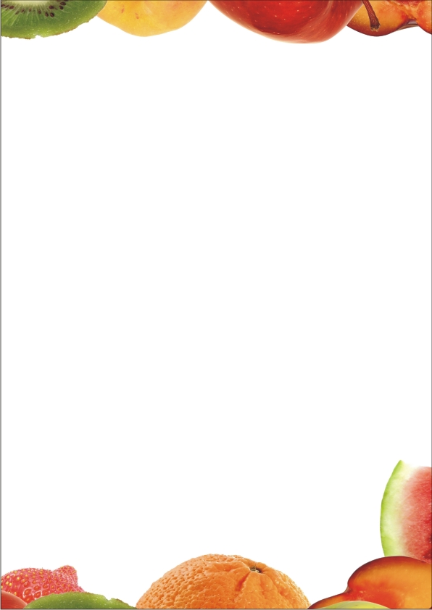](http://www.google.nl/url?sa=i&rct=j&q=&esrc=s&source=images&cd=&ved=0ahUKEwissvKIjczQAhVBDxQKHXVuBnkQjRwIBw&url=http%3A%2F%2Fwww.lynxdigiprint.nl%2F1764bBriefpapier_1680.htm%3Fu%3D2&v6u=https%3A%2F%2Fs-v6exp1-ds.metric.gstatic.com%2Fgen_204%3Fip%3D77.251.55.141%26ts%3D1480358158978481%26auth%3Djdiejnf4stedvup5cioyeihs62beshpr%26rndm%3D0.48938259302465214&v6s=2&v6t=319079&bvm=bv.139782543,d.ZGg&psig=AFQjCNFDM5tsfq97U7R2cIbHk8HP9FdiJQ&ust=1480444859633437)

Naam + klas